Table of Contents
Table of Contents 2
Lab 1-1 Creation of organization structure containing plant, storage location and purchasing organization 5
Lab 2-1 1 Assignment of above to company code and plant 6
Lab 3-1 Creation of material for customized material type and assignment of views to material type in configuration as well as masters 10
Lab 4-1 Creation of PO cycle 11

1) Creation of organization structure containing plant, storage location and purchasing organization
Goals | Create organizational structure for SAP MM working
Time | 120 Minutes
Prerequisite | Company code should be created by SAP FICO team

Components of organization structure-
1.Client
2.Company Code
3.Plant
4.Storage Location
4.Purchasing Organization
5.Purchasing Group

Organizational Structure

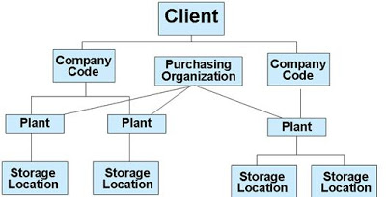

In the organizational structure, the top most level is CLIENT and COMPANY CODE defined by BASIS and FICO respectively.

1) Creation of Plant

Path:- SPRO >> SAP reference IMG >> Enterprise Structure >> Definition >> Logistics General >> Define, copy, delete, check plant
Transaction Code: OX10

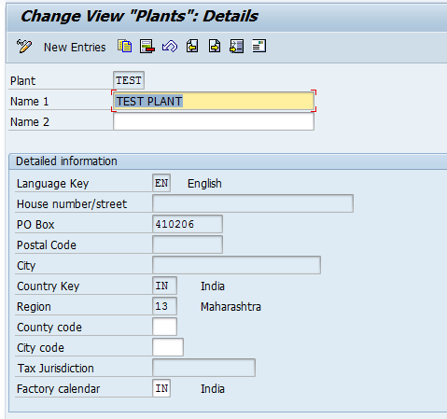

Thus plant (TEST) was successfully configured in SAP.

Creation of Storage Location
Path:- SPRO >> SAP reference IMG >> Enterprise Structure >> Definition >> Material Management >> Maintain Storage Location.
Transaction Code : OX09

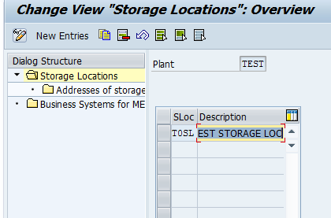

Thus new storage location (T0SL) has created.

Purchase Organization
Path:- SPRO >> SAP reference IMG >> Enterprise Structure >> Definition >> Material Management >> Maintain >> Maintain Purchasing organization
Transaction Code : OX08

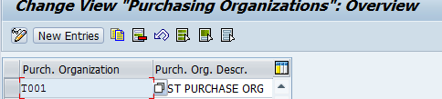

Thus new Purchasing organization (T001) has created.

Purchasing Group
Path:- SPRO >> SAP reference IMG >> Enterprise Structure >> Definition >> Material Management >> Purchasing >> Create Purchasing Group
Transaction Code : OME4
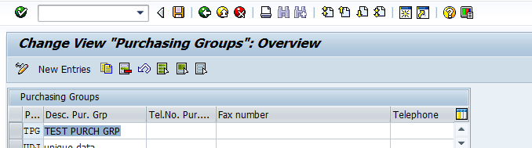

Thus new Purchasing Group (TPG) is created.

2) Assignment of above to company code and plant

Goals | Assignment of above to company code and plant
Time | 60 Minutes
Prerequisite | Plant, Company code and purchasing organization should be created.

Assignment of Plant to Company code:
Path:- SPRO >> SAP reference IMG >> Enterprise Structure >> Assignment >> Logistics General >> Assign company code to plant.
Transaction Code: OX18
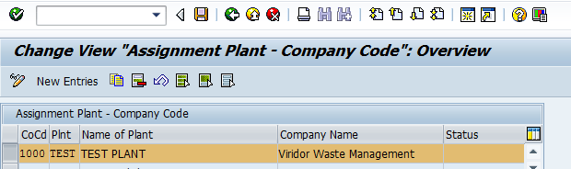

Assignment of purchasing organization to company code:
Path:- SPRO >> SAP reference IMG >> Enterprise Structure >> Assignment >> Material management >> Assign Purchase organization to company code.
Transaction Code: OX01

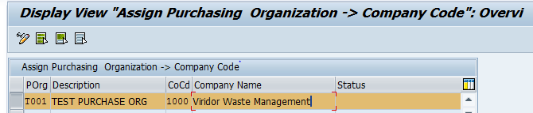

Assignment of purchasing organization to Plant:
Path:- SPRO >> SAP reference IMG >> Enterprise Structure >> Assignment >> Material management >> Assign Purchase organization to Plant.
Transaction Code: OX17
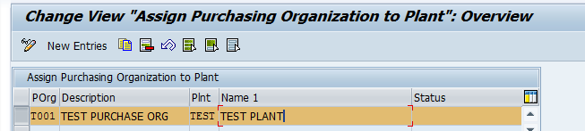

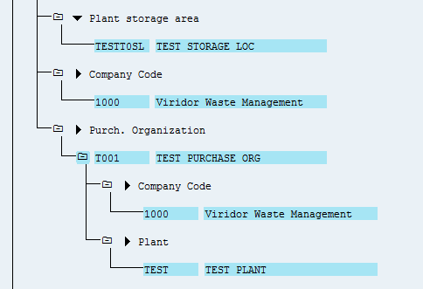

3) Creation of material for customized material type and assignment of views to material type in configuration as well as masters

Goals | Create material for customized material type
Time | 60 Minutes
Prerequisite | Plant and storage location should be created

Material type: A grouping together of materials with the same basic attributes such as raw materials, semi-finished products, or finished products.

Material type is used when we need to group together of materials with the same basic attributes.

Path:-SPRO >> Logistics-General >> Material Master >> Basic Settings >> Material Types >> Define attributes of material types.

Transaction Code:- OMS2

The new material type is created based on our requirement.

Some of the requirements are as follows,
- if you want to post in different account (Quantity or Value Update)
- If you want different number range.
- If you want different screen layout & field selection

Step 1) Enter T Code OMS2 in the SAP command field and press enter.

Step 2) List of material types are displayed in the screen, Select existing material type line item and click on “New Entries” or copy as icon to define new material types in SAP.

Material Type: - ZROH
Description: - Custom Raw material
Field Reference: ROH
Internal/external purchase orders:- Select the value as per business requirements, possible entries are allowed.

Step 3) Click on save icon and then select created material type and double click on quantity/value updating If it is not stock item tick only value updating, if it is a stock item with value tick the both quantity updating and value updating columns.

Click on save to save the configured material types data.

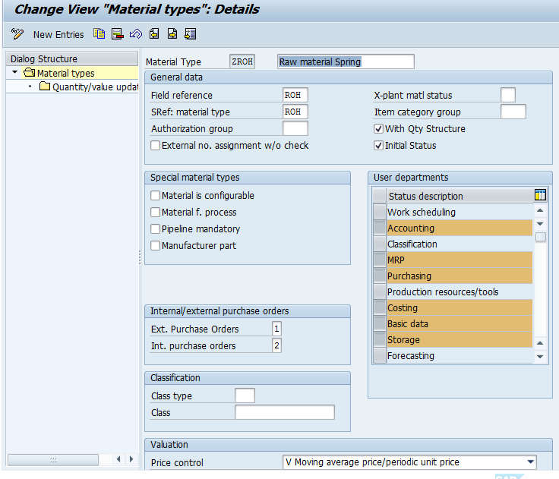

Step 4 : – Now choose the created material type TROH and click on quantity /value updating option.

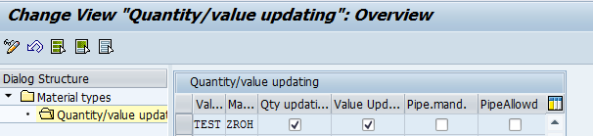

Create material master record-

You can maintain material master record (create material codes) in SAP by performing the following steps

Transaction code - MM01

SAP Menu Path - SAP Menu > Logistics > Material Management > Material Master > Material > Create (General) > MM01

Material created - 400000012

Display created material – MM03

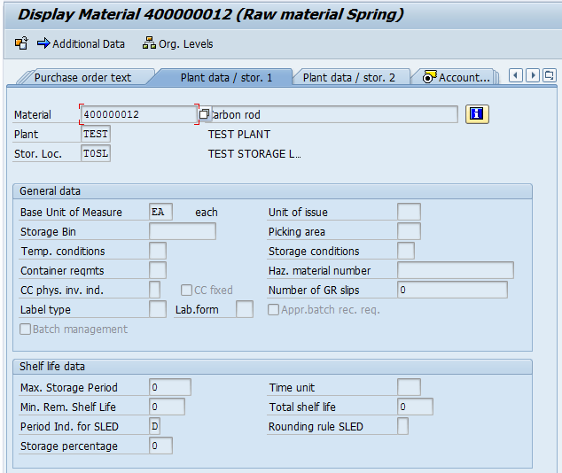

4) Creation of PO cycle
Goals | Create PR and PO
Time | 60 Minutes
Prerequisite | Material master and vendor master update

A Purchase Requisition can be created by following the steps given below −

Path to Create Purchase requisition
Logistics ⇒ Materials Management ⇒ Purchasing ⇒ Purchasing Requisition ⇒ Create

TCode: ME51N

Step 2 − Fill in all the required details such as name of the material, quantity, delivery date, material group, and plant. Click on Save. A new Purchase Requisition will be created.

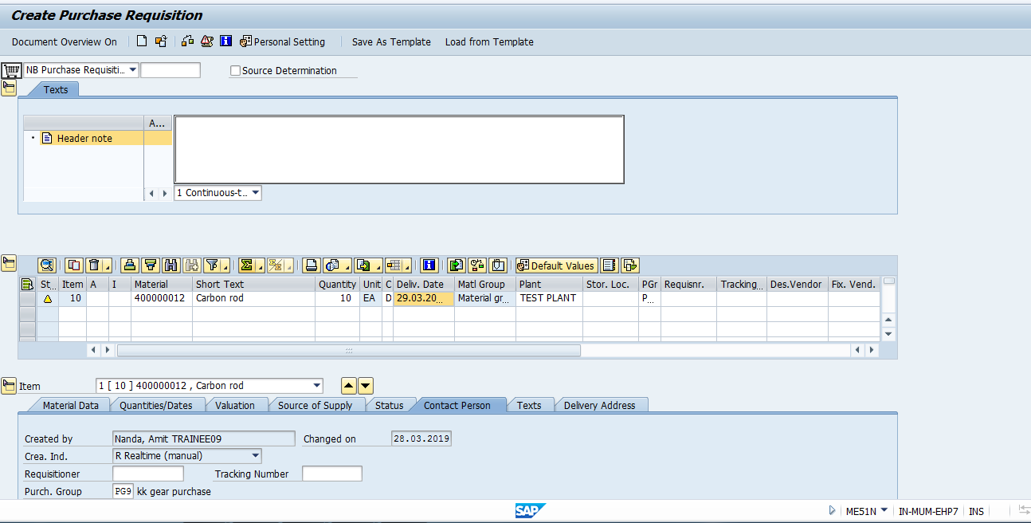

PR No - 0010000555

After creating a purchase requisition, we need to send our requirements to the vendor. It is done through a document that is known as the purchase order. A purchase order can be directly created from a purchase requisition.

Creating Purchase Order from Purchase Requisition
Follow the steps given below to create a purchase order from a purchase requisition. −

TCode: ME21N

Step 1 − Enter TCode to go to the purchase order home screen. Select Purchase Requisition as shown in the following screenshot.

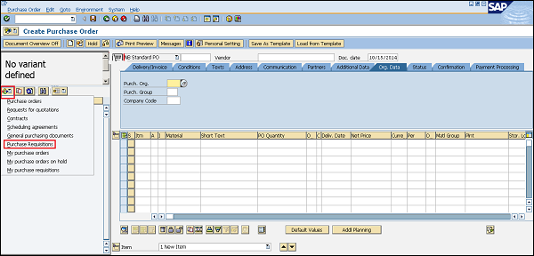
Step 2 − Provide the purchase requisition number for which you want to create a purchase order. Then select the execute icon.

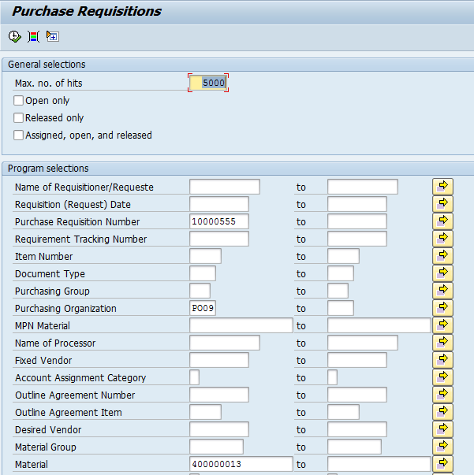

Step 4 − Verify the details of the purchase order and do the necessary changes as per requirement. Click on Save. You now have a purchase order from the selected purchase requisition

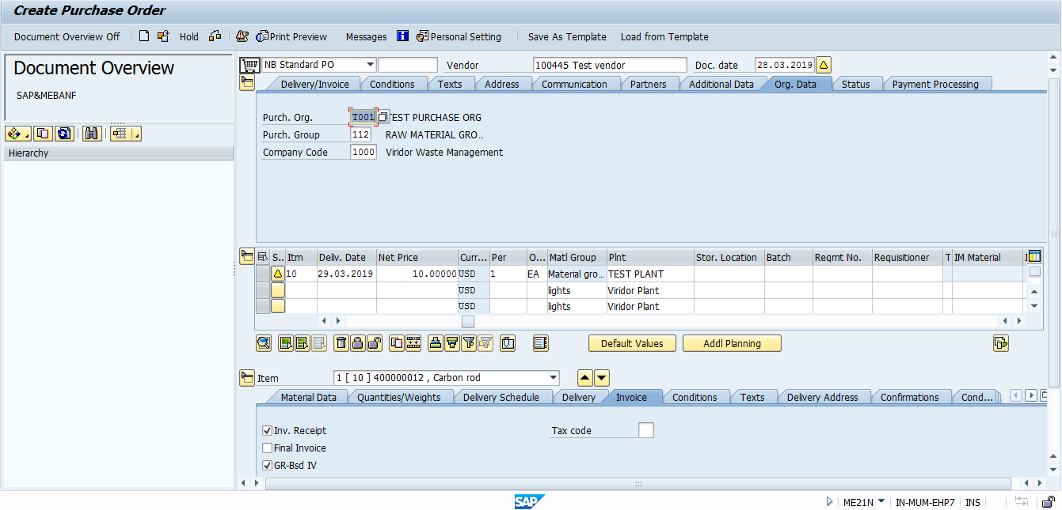

PO No – 4500000844

